**IT PROJECT MONITORING AND TRACKING SYSTEM**

**NIK HUSNEE NIK UMA**

**TYLAS MOEUT**

**FATONI UNIVERSITY**

**1440/2019**

# **CHAPTER IV**

# **IMPLEMENTATION AND RESULT**

The objective in this chapter is focus on the coding and testing the system according to the step that developers had suggested to implement in the IT Project Monitoring and Tracking System. And the results of the process moving an idea from concept to the reality. In this chapter also included how the developer’s done the system and explanation of how to use the system with some figures. The system will be tested by using the AppServ and correct any errors by using PHP language.

1. **IMPLMENTATION**

### The implementation is the core activity in the construction phase. In the implementation activity, the developer start coding the system specification in order to convert into the machine-readable computer code. At this activity, the developers use PHP language for coding and create the database by using MySQL to store the information of the system.

1. **RESULT AND USER INTERFACE**

User interface (UI) design is the process of making interfaces in software or computerized devices with a focus on looks or style. The IT Project Monitoring and Tracking system consist of four user subsystems; administrator, lecturer, officer and student. And this system we design into two type of user interfaces include backend design and frontend design.

### **Frontend Design**

#### The frontend design pages are the main page of the IT Project Monitoring and Tracking system. In these pages, the general user can manage after they access to the system. For the main page including menu functions as the figure below.

Figure 1 User interface of the main page of ITPROMOT system

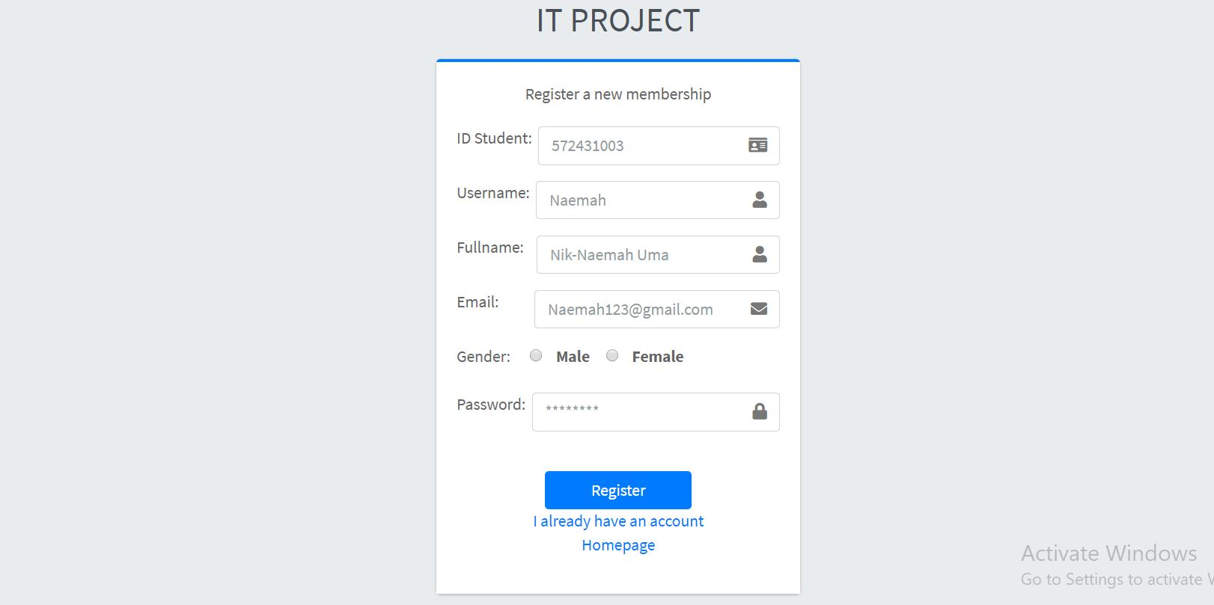According to the figure1 show the main page of ITPROMOT system. there are many of menu sidebars such as home page, announcement page, propose topic project page, proposal project page and others.

Figure 2 User interface of the register page of ITPROMOT system

According to the figure2 show the main page of ITPROMOT system. there are many of menu sidebars such as home page, announcement page, propose topic project page, proposal project page and others

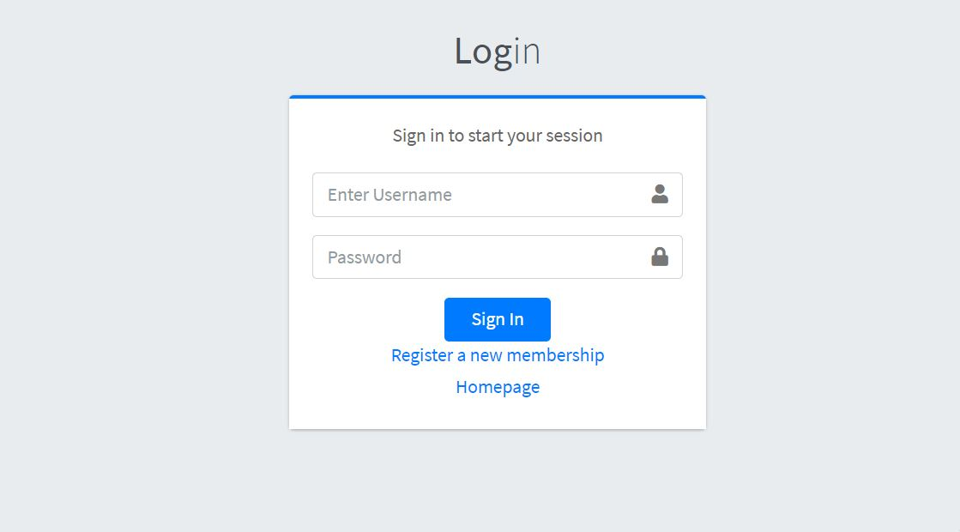Figure 3 User interface of Login page

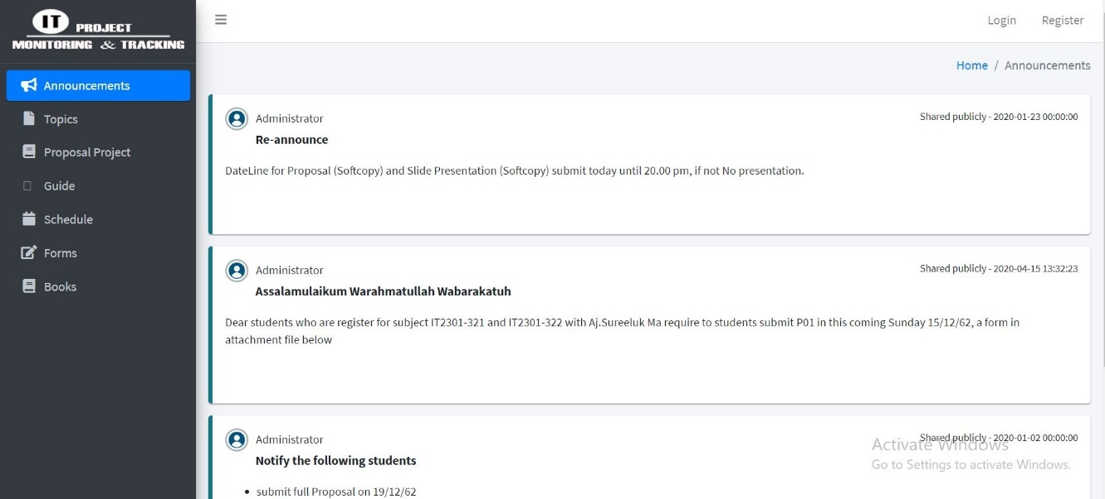According to figure3 show the admin and user’s login page. All of users have to have their own account for login to use this system. The lecturer and officer will receive the account from the admin but for student have to register and waiting for admin accept. In the login page users can key the username and password after they got the activation account from admin.

Figure 4 User interface of announcement

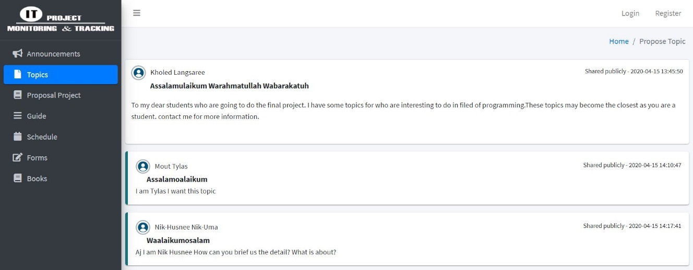In this figure4, show the announcement that publish by administrator to announce to all users.

*Figure 5 User interface of propose topic*

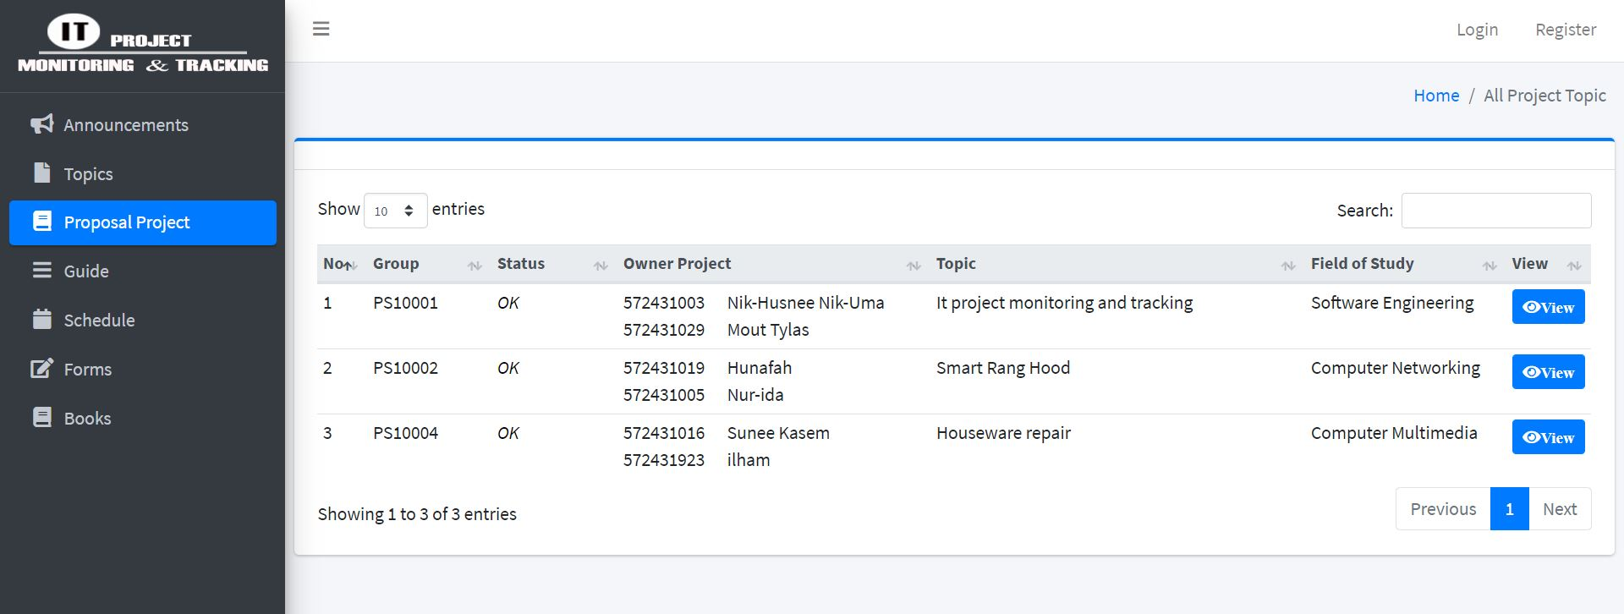According to figure5, show the page of propose project topic that publish by the lecturers in order to recommendation to the student who does not have the project to do yet.

Figure 6 User interface of view all project topics

According to figure6, show the all proposal/project topics that student has token. This page will display when the user clicks on the project topic at the menu sidebar then the page will direct to show the list of all student project topics with some details.

### **Backend Design**

Backend design pages is the management page for the four type of users in the ITPROMOT system; administrator, lecturer, officer and student. The users (administrator, lecturer, officer and student) must login before enter to the management dashboard to perform the functions on this page.

1. 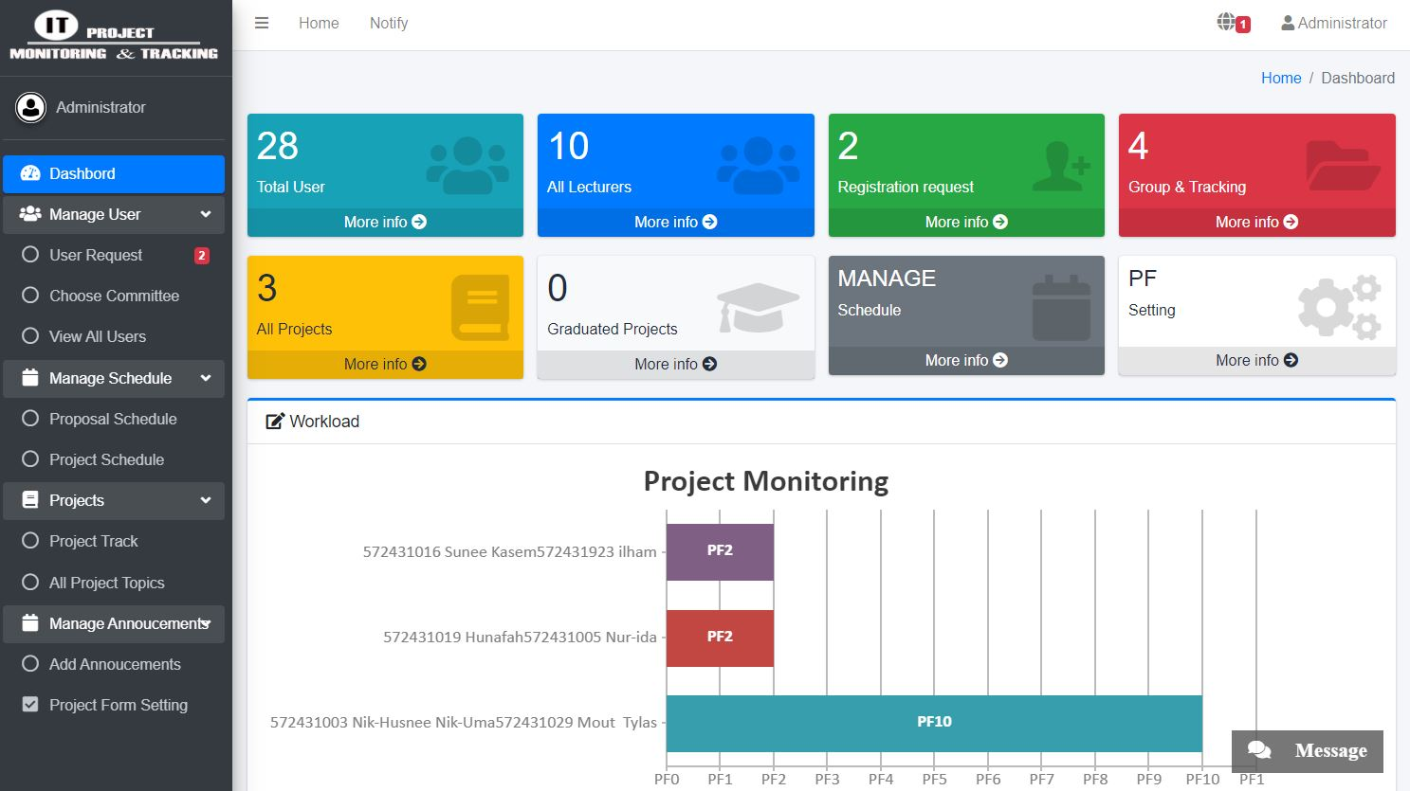**Administrator Subsystem**

Figure 7 The dashboard management of Administrator

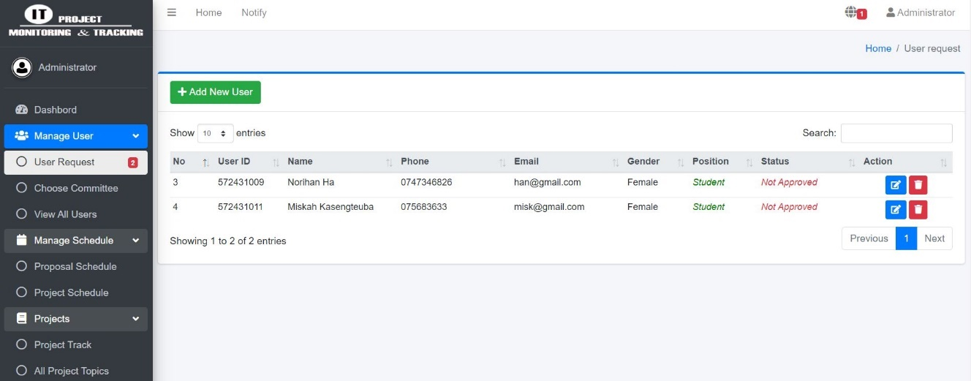In this figure7, show the administrator dashboard management. The function includes request of user, manage user, manage project, manage schedule, manage announcement and which function will discuss in the next figure.

Figure 8 Administrator Manage user (respond the user’s request)

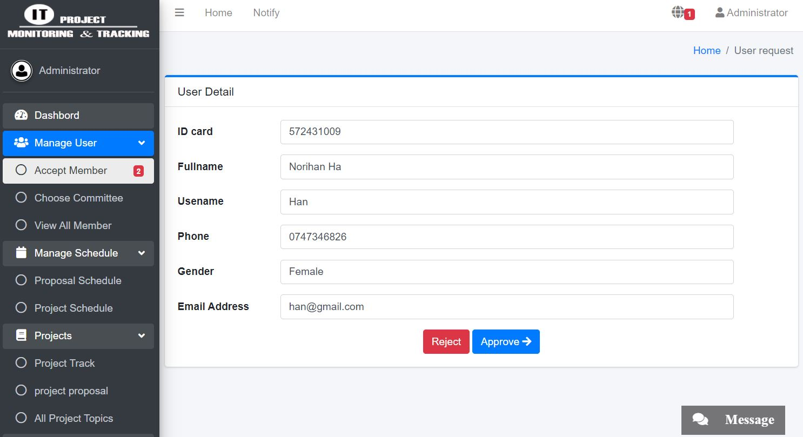

Figure 9 Administrator Manage user (respond the user’s request)

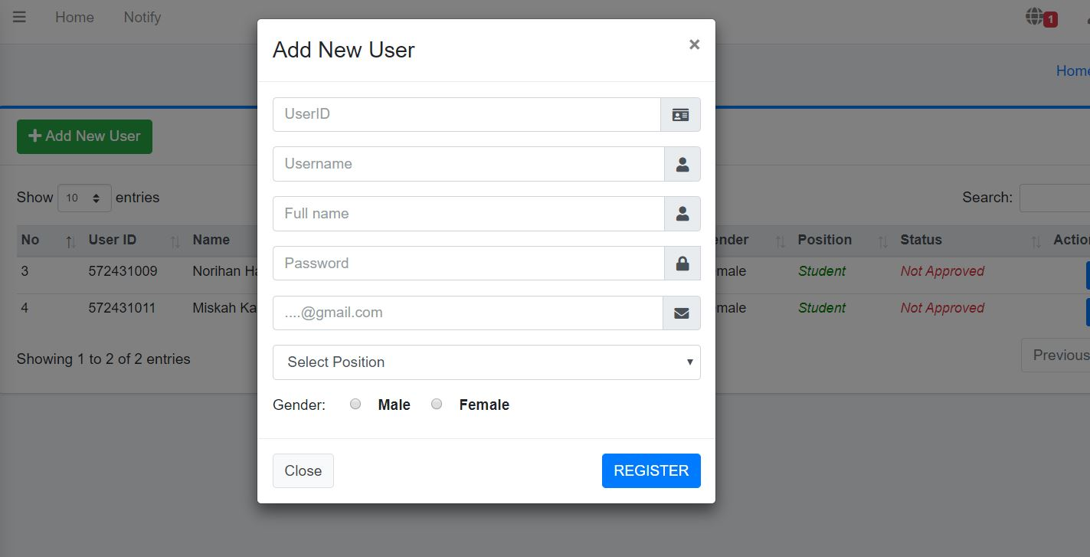In the figure8 and figure9, show the administrator can view the user register request. Admin can accept or reject the user’s request to use in this system. If admin accept, the message will direct to the email of own user. Else nothing happens.

Figure 10 Administrator add new user

In this figure10, show the administrator can add new user that include userID, Username, Fullname, password, email, position and gender.

Figure 11 Administrator choose committee to student

In this figure11, show the administrator can choose committee to the student by select the lecturer.

*Figure … Administrator view all user*

In this figure… show the administrator can view all user in the system and also can update and delete users also.

*Figure … Administrator manage schedule*

In this figure… show the administrator can manage the schedule (proposal and project) by click on the manage schedule at the menu sidebar then the page will direct to page that include view, update, add and delete.

*Figure … Administrator manage project (track project)*

In this figure… show the administrator can track the student project by click on the project button at the sidebar. Then the information of student group will display. Admin can click on the view track to see the tracking information of student.

*Figure … Administrator manage the announcement*

In this figure… show the administrator can manage the announcement by click on the announcement button then the page will direct to page that include view, update, add and delete.

1. **Lecture Subsystem**

This is all function which lecturer can perform. The function of lecturer as show in the dashboard management in the figure … the function includes request, project management, schedule, propose topic and others.

*Figure … Lecturer dashboard management*

*Figure … Lecturer can accept/reject the student request*

In this figure… show the page of all requests form from student to the lecturer. This page will display when the lecturer clicks on the request button at the menu sidebar. The request page includes all the forms of the project operation with the status that lecturer can accept or reject.

*Figure … Lecturer can update the proposal/project status*

In this figure… show the all proposal/project detail of student. In this page the lecturer can update the proposal/project status of the student to know where the project operation of student stands on.

*Figure … Lecturer can track the project*

In this figure… show the project tracking page by click on the project function and the menu sidebar then the sub functions of the project will show. Lecturer selects on the project track to track the project of his/her student’s group. The page will direct to page that include some detail and view track to know which step this group stay in.

*Figure … Lecturer can view schedule*

In this figure… show the page that lecturer can view the schedule of proposal/project by click on the schedule at the menu sidebar. Lecturer can select the schedule category (proposal or project) in order to view the detail.

*Figure … Lecturer can add the propose topic*

In this figure… show page that lecturer can add the propose topic to recommendation to the student who interest by click on the propose topic at the menu sidebar then the page will direct to display the all detail of propose topics with include add, view, update, and delete button.

*Figure …User interface of committee*

In this figure… show the page that lecturer be as the committee. This page will display when the lecturer chooses for committee function at the menu sidebar. In this page, include the forms that student has requested to committee.

1. **Officer Subsystem**

*Figure …User interface of officer dashboard*

In this figure… show the dashboard management with all functions that officer can perform. This page will display after the officer login successfully. The function in this page include request page, track project page, schedule and else.

*Figure …User interface of request page*

In this figure… show the request page that student request some form to the officer. In this page will show the detail of the student request form and officer can accept or reject.

*Figure …User interface of officer can view track of student*

In this figure… show the list of the student’s group that officer can view the track by click on the student track at the menu sidebar. The page will direct to display the list and details of the student’s group.

*Figure …User interface of officer can add schedule*

In this figure… show the page that officer can add the schedule (proposal or project) by click on the schedule at the menu sidebar. The page will direct to display the page that include view, add, update and delete the schedule.

1. **Student Subsystem**

After login successful, page will directly to the student management dashboard show in the figure… This is all the functions which student can perform. The function includes group information, project management, schedule, news, profile and manage web board. Each function will discuss in the next figure.

*Figure …User interface of student dashboard*

*Figure …User interface of group information*

According to the figure… show the group information. In this page will display all the details of group as student information, partner information, advisor information and committee information.

*Figure …User interface of group information (join group)*

According to the figure… show student join the group with their partner by click on the add group button to create the group first if the student does not create the group yet. After student created the group, student has to join the group that student was created by click on the join partner button. The information will display at the table below.

*Figure …User interface of group information (request advisor)*

In this figure… show student can request the lecturer to be their advisor by click on the request advisor button. Then the page will pup up with the form of selection the lecturer. Student has to wait the approval from the lecturer after finished the requesting.

*Figure …User interface of student can add the proposal*

In this figure … show student can add some details of proposal by click on the project button at the menu sidebar then the sub function will appear. Student selects add proposal button for add, update and view proposal detail.

*Figure… User interface of student track project*

In this figure… show student can track the project by select the project category at the project track button. The tracking project page will display all forms step by step to list all the student has to carry out.

1. **TESTING RESULR**

The testing result, developers define that the result must more than or equal to 50

percent of all function in test case. If the result is less than 50 percent, that function will be failed in test case. ​This system we test with three of testers and each case function must test two rounds.

|  |  |  |  |  |  |  |  |  |
| --- | --- | --- | --- | --- | --- | --- | --- | --- |
| No | Test case | Round 1 | | | Round 2 | | | Result |
| P1 | P2 | P3 | P1 | P2 | P3 |
| **Registration** | | | | | | | | |
| 1 | Student register to be user |  |  |  |  |  |  |  |
| Total | | | | | | | |  |
| **Login** | | | | | | | | |
| 2 | Admin login |  |  |  |  |  |  |  |
| 3 | Lecturer login |  |  |  |  |  |  |  |
| 4 | Officer login |  |  |  |  |  |  |  |
| 5 | Student login |  |  |  |  |  |  |  |
| Total | | | | | | | |  |
| **Manage Users** | | | | | | | | |
| 6 | Admin can choose committee to student |  |  |  |  |  |  |  |
| 7 | Admin can CRUD user account |  |  |  |  |  |  |  |
| 8 | Admin can accept/reject user’s request registration |  |  |  |  |  |  |  |
| Total | | | | | | | |  |
| **Manage Announcement/ propose topic** | | | | | | | | |
| 9 | Admin can CURD announcement |  |  |  |  |  |  |  |
| 10 | Lecturer can CRUD propose topic |  |  |  |  |  |  |  |
| Total | | | | | | | |  |
| **Manage project/proposal detail** | | | | | | | | |
| 11 | Admin can CRUD project proposal |  |  |  |  |  |  |  |
| 12 | Student can CRUD project proposal |  |  |  |  |  |  |  |
| 13 | Lecturer can update proposal status |  |  |  |  |  |  |  |
| Total | | | | | | | |  |
| **View all project topics** | | | | | | | | |
| 14 | Admin can view all project topics |  |  |  |  |  |  |  |
| 15 | Lecturer can view all project topics |  |  |  |  |  |  |  |
| 16 | Officer can view all project topics |  |  |  |  |  |  |  |
| 17 | Student can view all projects |  |  |  |  |  |  |  |
| Total | | | | | | | |  |
| **Manage schedule** | | | | | | | | |
| 18 | Admin can CRUD schedule |  |  |  |  |  |  |  |
| 19 | Officer can RRUD schedule |  |  |  |  |  |  |  |
| Total | | | | | | | |  |
| **View schedule** | | | | | | | | |
| 20 | Admin can view schedule |  |  |  |  |  |  |  |
| 21 | Lecturer can view schedule |  |  |  |  |  |  |  |
| 22 | Officer can schedule |  |  |  |  |  |  |  |
| 23 | Student can view schedule |  |  |  |  |  |  |  |
| Total | | | | | | | |  |
| **Request** | | | | | | | | |
| 24 | Student can request advisor |  |  |  |  |  |  |  |
| 25 | Student can request project topic |  |  |  |  |  |  |  |
| 26 | Student can request registration |  |  |  |  |  |  |  |
| Total | | | | | | | |  |
| **Respond request** | | | | | | | | |
| 27 | Admin can accept/reject registration’s request |  |  |  |  |  |  |  |
| 28 | Lecturer can accept/reject advisor request |  |  |  |  |  |  |  |
| Total | | | | | | | |  |
| **Join group** | | | | | | | | |
| 29 | Student can join group with partner |  |  |  |  |  |  |  |
| Total | | | | | | | |  |
| **Project Track** | | | | | | | | |
| 30 | Student can track project |  |  |  |  |  |  |  |
| 31 | Admin can track project |  |  |  |  |  |  |  |
| 32 | Lecturer can track project |  |  |  |  |  |  |  |
| 33 | Officer can track project |  |  |  |  |  |  |  |
| Total | | | | | | | |  |
| **View project progress** | | | | | | | | |
| 34 | Admin can view project progress |  |  |  |  |  |  |  |
| 35 | Lecturer can view project progress |  |  |  |  |  |  |  |
| 36 | Officer can view project progress |  |  |  |  |  |  |  |
| 37 | Student can view project progress |  |  |  |  |  |  |  |
| Total | | | | | | | |  |
| **File sharing** | | | | | | | | |
| 38 | Student can upload/download file |  |  |  |  |  |  |  |
| 39 | Lecturer can download file |  |  |  |  |  |  |  |
| Total | | | | | | | |  |
| **Forum chatting** | | | | | | | | |
| 40 | Student can communicate with lecturer |  |  |  |  |  |  |  |
| 41 | Lecturer can communicate with student |  |  |  |  |  |  |  |
| Total | | | | | | | |  |
| **Notification** | | | | | | | | |
| 42 | Admin can CRUD notification |  |  |  |  |  |  |  |
| 43 | Lecturer can CRUD notification |  |  |  |  |  |  |  |
| 44 | Officer can view notification |  |  |  |  |  |  |  |
| 45 | Student can view notification |  |  |  |  |  |  |  |
| Total | | | | | | | |  |
| **Manage Mark** | | | | | | | | |
| 46 | Admin can CRUD mark | Repeal |  |  |  |  |  |  |
| 47 | Lecturer (advisor) can CRUD mark | Repeal |  |  |  |  |  |  |
| 48 | Lecturer (Committee) can give pass/not pass | Repeal |  |  |  |  |  |  |
| Total | | | | | | | |  |
| **Total all functions** | | | | | | | |  |

Table …: summary test case functions

According table…to the description before, developer define that the result must more than or equal to 50 percent of all function in test case. If the result is less than 50 percent, that function will be failed in test case. Almost the function in test case is complete that mean the total all function is pass.

# **CHAPTER V**

# **CONCLUSION**

The aim of IT Project Monitoring and Tracking System is developed base on the requirement specification of the user and the analysis of the existing system, with flexibility for future enhancement. This system provides for Administrator, lecturer, officer and student of IT department to perform the take by electronically. The objective of this chapter describes objective achievement of the system development as well as recommendation and limitation from the development term.

1. **RECOMMENDATION**

Currently, The IT Project Monitoring and Tracking System is providing four subsystems; Administrator, Lecturer, Officer and Student in IT department. This system has function that can track and monitor for the IT project course of the student who are registered for this course. The recommendation to those who interest in this project for the future developer is needed to address several issues pertaining to mention, include the following:

* The system should be developed to be able to alert the user through various methods such as email or telephone as an automatic prototype for reduce the process of direct tracking of user and increase efficiency in tracking project progress.
* Develop a system to be notified of events or events in the form of SMS to mobile phones of the system user
* The system should be developed to be able to use the electronic signature in the system to approve the document.

1. **LIMITATION**

The IT Project Monitoring and Tracking System is developed in web application system for IT department of Fatoni University to tracking and monitor the IT project of student who are registered in the IT project course. The limitation of this project as following:

* This project system can not run without the internet
* This project system can use only for the student who are registered the IT project course of IT department of Fatoni University.
* This project system can run on the web browser only
* This project system can use only in English

While the developers construct the project, there are some function could not complete as the following description:

* Manage mark obtain
* Give mark as the advisor /committee